# Architecture Design

## System Architect

## Software Architect

## Source code Structure

# Graphic Design

## Login

## Register

## Finance Statistic (Home page)

## Account Info

## Add Activity

## Item Detail

## Cash Statistic

# Database Design

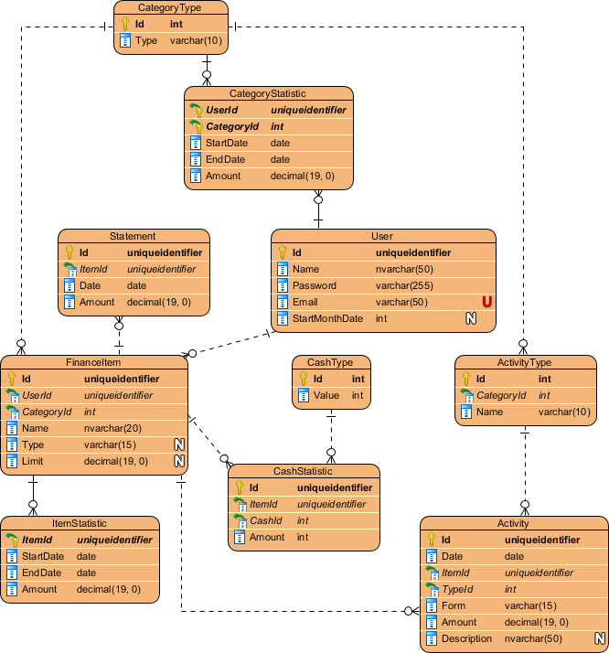

# Detail Design

## Authentication

### Login

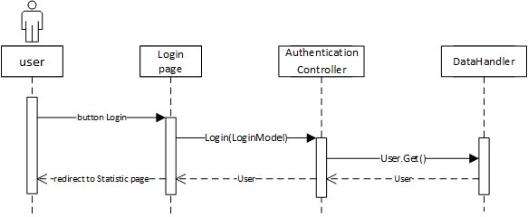

### Logout

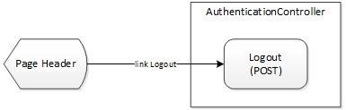

## Account

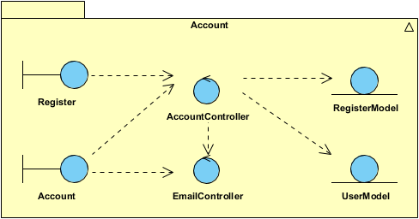

### Register

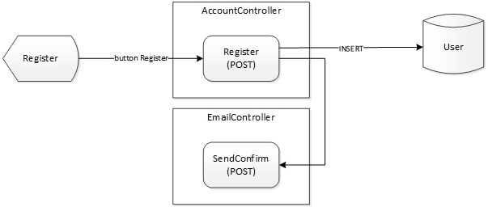

### Update Info

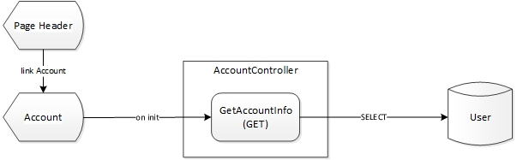

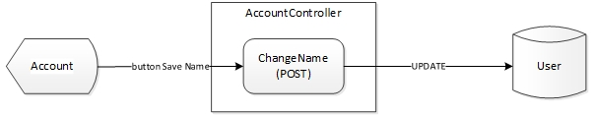

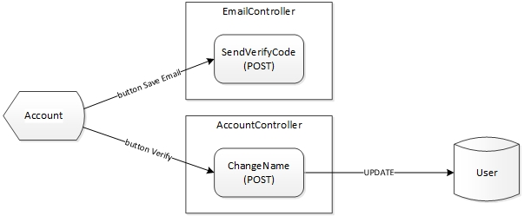

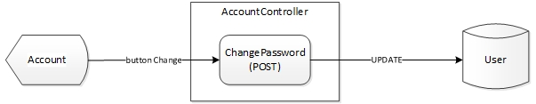

## Finance

Statistic

Item

Activity

|  |  |  |  |  |
| --- | --- | --- | --- | --- |
| Module | Class | | Attributes & Methods | |
| **Name** | **Type** | **Datatype** | **Name** |
| Authentication | AuthenticationController | Controller |  | Login() |
|  | Logout() |
| LoginModel | Model | string | Email |
| string | Password |
| Account | AccountController | Controller |  | Register() |
| object | GetAccountInfo() |
|  | ChangeName() |
|  | ChangeEmail() |
|  | ChangePassword() |
| RegisterModel | Model | string | Name |
| string | Email |
| UserModel | Model | Guid | Id |
| string | Name |
| string | Password |
| string | Email |
| Finance | ItemController | Controller |  | AddItem() |
|  | AddEditResidual() |
|  | AddCredit() |
|  | EditCreditLimit() |
|  | EditCreditStatement() |
| CashController | Controller | object | GetCashData() |
|  | AddEditCash() |
|  | DeleteCash() |
| ActivityController | Controller |  | AddActivity() |
| object | GetActivityData() |
|  | EditActivity() |
|  | DeleteActivity() |
| StatisticController | Controller | object | GetCategoryStatistic() |
| object | GetItemStatistic() |
| object | ChangeMonthRange() |
| StatisticBusiness | Business |  | ChangeCash() |
|  | ChangeCreditLimit() |
|  | ChangeStatistic() |
| StatisticConditionModel | Model | string | StartDate |
| string | EndDate |
| CategoryModel | Model | int | Id |
| string | Name |
| CategoryDetailModel | Model |  | *inherite CategoryModel* |
| DateTime | StartDate |
| DateTime | EndDate |
| double | Amount |
| ItemModel | Model | Guid | Id |
| int | Category |
| string | Name |
| ItemDetailModel | Model |  | *inherite ItemModel* |
| DateTime | StartDate |
| DateTime | EndDate |
| double | Amount |
| ItemResidualModel | Model |  | *inherite ItemModel* |
| DateTime | StartDate |
| DateTime | EndDate |
| string | Type |
| double | Amount |
| ItemCreditModel | Model |  | *inherite ItemModel* |
| double | TotalLimit |
| ItemCreditDetailModel | Model |  | *inherite ItemCreditModel* |
| DateTime | StartDate |
| DateTime | EndDate |
| double | Used |
| double | CurentLimit |
| double | Statement |
| StatementModel | Model | Guid | Item |
| DateTime | Date |
| double | Amount |
| ActivityTypeModel | Model | int | Id |
| int | Category |
| string | Name |
| ActivityStatisticModel | Model | Guid | id |
| DateTime | Date |
| Guid | Item |
| int | Type |
| string | TypeName |
| string | Form |
| double | Amount |
| string | Description |
| CashTypeModel | Model | int | Id |
| int | Value |
| CashStatisticModel | Model | Guid | Id |
| Guid | Item |
| int | Cash |
| int | CashValue |
| int | Amount |

# Program Design

## Authentication

### Login

### Logout

## Account

### Register

### Update Info

## Statistic

## Item

## Activity